Supplementary Material
Supplementary Table 1. Annual natural history transition probabilities (%) for EDSS states¹
EDSS | 0 | 1 | 2 | 3 | 4 | 5 | 6 | 7 | 8 | 9 | 10
  From/to
0 | 69.54 | 20.29 | 7.25 | 2.17 | 0.42 | 0.14 | 0.18 | 0.01 | 0.00 | 0.00 | 0.00
1 | 5.83 | 69.50 | 15.78 | 6.09 | 1.64 | 0.46 | 0.64 | 0.05 | 0.01 | 0.00 | 0.00
2 | 1.59 | 12.13 | 60.79 | 16.80 | 4.46 | 1.85 | 2.16 | 0.17 | 0.05 | 0.00 | 0.00
3 | 0.59 | 4.96 | 12.01 | 54.42 | 9.11 | 5.85 | 11.65 | 1.03 | 0.36 | 0.03 | 0.00
4 | 0.17 | 2.21 | 6.66 | 11.52 | 48.94 | 10.39 | 16.81 | 2.58 | 0.67 | 0.06 | 0.00
5 | 0.05 | 0.53 | 2.94 | 5.87 | 8.74 | 48.70 | 27.31 | 3.88 | 1.88 | 0.10 | 0.00
6 | 0.01 | 0.13 | 0.44 | 2.50 | 3.07 | 4.08 | 74.07 | 10.90 | 4.38 | 0.42 | 0.00
7 | 0.00 | 0.02 | 0.05 | 0.25 | 0.73 | 0.39 | 11.68 | 69.27 | 16.06 | 1.56 | 0.00
8 | 0.00 | 0.00 | 0.00 | 0.03 | 0.06 | 0.05 | 1.88 | 5.57 | 90.34 | 2.07 | 0.00
9 | 0.00 | 0.00 | 0.00 | 0.00 | 0.00 | 0.00 | 0.18 | 0.57 | 17.41 | 81.83 | 0.00
10 | 0.00 | 0.00 | 0.00 | 0.00 | 0.00 | 0.00 | 0.00 | 0.00 | 0.00 | 0.00 | 100.00
¹ [1]
Abbreviations: EDSS - expanded disability status scale.
Note: This table was reproduced from Baharnoori et al. 2022 Pharmacoecon Open. http://creativecommons.org/licenses/by-nc/4.0/.

Supplementary Table 2. EDSS-dependent mortality multiplier and disability weights for MS and number of hospitalization days per year
Health state (EDSS) | Mortality HR¹ | Disability weights² | Hospitalization days per year³
0 | 1.00 | 0.000 | 0.00
1 | 1.43 | 0.011 | 0.00
2 | 1.60 | 0.021 | 3.00
3 | 1.64 | 0.110 | 3.00
4 | 1.67 | 0.199 | 4.00
5 | 1.84 | 0.256 | 4.00
6 | 2.27 | 0.313 | 7.00
7 | 3.10 | 0.617 | 10.00
8 | 4.45 | 0.772 | 22.17
9 | 6.45 | 0.926 | 60.74
10 | - | 1.000 | -
¹ [2]
² [3]
³ Assumption, validated by clinician input.
Abbreviations: EDSS - expanded disability status scale; HR - hazard ratio.

Supplementary Table 3. Productivity loss per year due to MS
Health state (EDSS) | % Employed¹ | % Working full time¹ | Informal care days² | % Retired early²
0 | 75.00ª | 64.10 | 15.66 | 11.00
1 | 61.50 | 49.90 | 15.66 | 11.00
2 | 48.80 | 35.70 | 15.66 | 11.00
3 | 36.20 | 23.70 | 15.66 | 11.00
4 | 25.30 | 14.80 | 48.66 | 43.00
5 | 16.80 | 8.81 | 48.66 | 43.00
6 | 10.70 | 5.11 | 48.66 | 43.00
7 | 6.69 | 2.92 | 93.60 | 40.00
8 | 0.00ª | 0.00ª | 93.60 | 100.00ª
9 | 0.00ª | 0.00ª | 93.60 | 100.00ª
10 | 0.00ª | 0.00ª | 0.00 | 0.00
¹ The % of patients employed and working full time for EDSS 1 to 6 were obtained from Grima et al. [4]. Values for the remaining health states were based on extrapolations and clinician input.
² The number of informal care days per year were calculated based on the number of informal care hours per patient per year from Karampampa et al. [5] divided by an 8-hour workday. The % of patients retiring early were sourced from Karampampa et al. [5] based on EDSS state groupings
ª Values were modified based on clinician input
Abbreviations: EDSS - expanded disability status scale.
Supplementary Table 4. Treatment efficacy and discontinuation probabilities for ofatumumab and comparators versus BSC from the network meta-analysis¹
Treatment | 6-month confirmed disability progression,  HR (SE) | Annualized relapse rate,  RR (SE) | Discontinuation probabilities,  Risk (SE)
First-line therapies
Ofatumumab | 0.43 (0.12) | 0.30 (0.05) | 10.64% (0.76%)
Ocrelizumab | 0.47 (0.16) | 0.33 (0.05) | 10.95% (2.93%)
Teriflunomide | 0.80 (0.15) | 0.66 (0.06) | 13.12% (1.33%)
Dimethyl fumarate | 0.68 (0.12) | 0.50 (0.06) | 12.24% (2.28%)
Glatiramer acetate | 0.78 (0.15) | 0.65 (0.10) | 11.54% (2.23%)
Avonex | 0.71 (0.12) | 0.79 (0.06) | 13.22% (2.07%)
Rebif 44 | 0.77 (0.21) | 0.62 (0.05) | 15.06% (1.69%)
Betaseron | 0.79 (0.14) | 0.68 (0.07) | 10.54% (2.75%)
Extavia | 0.79 (0.14) | 0.68 (0.07) | 10.54% (2.75%)
BSC | 1.00 (0.00) | 1.00 (0.00) | 0.00% (0.00%)
Second-line therapies
Cladribine | 0.54 (0.13) | 0.42 (0.07) | 9.02% (3.63%)ª
Natalizumab | 0.46 (0.10) | 0.31 (0.05) | 11.25% (3.20%)
Fingolimod | 0.67 (0.11) | 0.46 (0.05) | 11.44% (2.33%)
¹[6]
ª Given the limited data and high level of uncertainty regarding treatment discontinuation rates for induction therapies, the all-cause discontinuation probability for cladribine was adjusted to 16% after 2 years, as previously suggested for modelling other induction therapies [7].
Abbreviations: BSC - best supportive care; HR - hazard ratio; RR - relative risk; SE - standard error.
Note: This table was reproduced from Baharnoori et al. 2022 Pharmacoecon Open. Minor modifications were made to exclude certain comparators. http://creativecommons.org/licenses/by-nc/4.0/.

Supplementary Table 5. Costs by health state
Health state (EDSS) | Direct medical cost^{1,2,3, a} (SE) (CAD)
0 | $1,268 ($254)
1 | $1,908 ($382)
2 | $2,590 ($518)
3 | $4,218 ($844)
4 | $5,837 ($1,167)
5 | $9,746 ($1,949)
6 | $15,143 ($3,029)
7 | $36,461 ($7,292)
8 | $43,217 ($8,643)
9 | $52,936 ($10,587)
¹ (Grima et al., 2000)
² [5]
³ [8]
ª Total direct medical costs per patient for EDSS 1-6 were sourced from Grima et al. [4], while those for the remaining EDSS states were calculated based on exponential extrapolation according to the systematic review by Patwardhan et al. [8]. Professional care costs were added to the total health state costs, as previously suggested [5, 9].
Abbreviations: CAD - Canadian dollars; EDSS - expanded disability status scale; SE - standard error.

Supplementary Table 6. Drug administration, monitoring, and adverse event costs
Treatment | Total cost Y1 (CAD) | Total cost  Y2+ (CAD) | AE Annual Costsª (CAD) | References
First-line therapies
Ofatumumab | $1,136 | $38 | $42 | [10-13]
Ocrelizumab | $3,374 | $1,581 | $52 | [10-16]
Teriflunomide | $1,196 | $38 | $38 | [10-13]
Dimethyl fumarate | $1,141 | $74 | $64 | [10-13]
Glatiramer acetate | $1,125 | $38 | $55 | [10-13]
Avonex | $1,261 | $84 | $54 | [10-13]
Rebif 44 | $1,261 | $84 | $56 | [10-13]
Betaseron | $1,631 | $70 | $53 | [10-13]
Extavia | $1,631 | $70 | $53 | [10-13]
BSC | $0 | $0 | $0
Second-line therapies
Cladribine^{b} | $1,158 | $82 | $57 | [10-13]
Natalizumab | $6,397 | $3,681 | $56 | [10-14]
Fingolimod | $1,682 | $84 | $68 | [10-13]
ª AE costs were calculated as total weighted costs based on probability of non-serious and serious events for each comparator.
^{b} The costs for cladribine were only applied in the first two years unless the patient was treated with a third dose (25.6% of patients) [17], in which case the costs for cladribine would also be applied to year 3.
Abbreviations: AE - adverse event; BSC - best supportive care; CAD - Canadian dollars; Y1 - year 1; Y2+ - years 2 onward.
Note: This table was reproduced from Baharnoori et al. 2022 Pharmacoecon Open. Minor modifications were made to exclude certain comparators. http://creativecommons.org/licenses/by-nc/4.0/.

Supplementary Table 7. Drug administration costs
Treatment | Resource | Annual resource use  Y1 (units) | Total cost Y1 (CAD) | Annual resource use  Y2+ (units) | Total cost  Y2+ (CAD) | References
First-line therapies
Ofatumumab | 2h of MS nurse time to teach self-administration | 2 | $76.46 | - | - | [10]
Glatiramer acetate
Avonex
Rebif 44
Betaseron
Extavia
Teriflunomide | 1h of MS nurse time to answer telephone questions about AEs | 1 | $38.23 | - | - | [10]
Dimethyl fumarate
Ocrelizumab | IV administration | 3 | $2,302 | 2 | $1,535 | [14]
Ocrelizumab | Methylprednisolone (1000 mg) | 0.3 | $11.38 | 0.2 | $7.59 | Alberta Formulary [16]
Ocrelizumab | Antihistamine 10 mg QD | 3 | $1.18 | 2 | $0.79 | ODB Formulary [15]
Ocrelizumab | Acetaminophen 500 mg QD | 3 | $0.09 | 2 | $0.06 | ODB Formulary [15]
Second-line therapies
Cladribineª | 1h of MS nurse time to answer questions about AEs | 1 | $38.23 | - | - | [10]
Natalizumab | IV administration | 13.04 | $3,559 | 13.04 | $3,559 | [14]
Fingolimod | Day case, 6h ECG and blood pressure monitoring | 1 | $362.92 |  |  | [13]
ª Cladribine was assumed to be equivalent to dimethyl fumarate (another oral medication).
Abbreviations: AE - adverse event; ECG - electrocardiogram; h - hour; IV - intravenous; MS - multiple sclerosis; OCCI - Ontario Case Costing Initiative; ODB - Ontario Drug Benefit; QD - daily; Y1 - year 1; Y2+ - year 2 onwards.
Note: This table was reproduced from Baharnoori et al. 2022 Pharmacoecon Open. Minor modifications were made to exclude certain comparators. http://creativecommons.org/licenses/by-nc/4.0/.

Supplementary Table 8. Drug monitoring costs
Treatment | Resource | Annual resource use  Y1 (units) | Total cost Y1 (CAD) | Annual resource use  Y2+ (units) | Total cost Y2+ (CAD) | References
First-line therapies
Ofatumumab  Ocrelizumab | Neurology visit  MS nurse visit (30 min)  MRI  HBV test | 1  2  1  1 | $178.60  $38.23  $832.09  $10.25 | -  2  -  - | -  $38.23  -  - | [10-13]
Teriflunomide | Neurology visit  MS nurse visit (30 min)  MRI  Full blood counts  Liver function tests  Tuberculin skin test  Pregnancy test | 1  2  1  1  7  1  0.68 | $178.60  $38.23  $832.09  $3.98  $82.39  $19.95  $2.64 | -  2  -  -  -  -  - | -  $38.23  -  -  -  -  - | [10-13]
Dimethyl fumarate | Neurology visit  MS nurse visit (30 min)  MRI  Full blood counts  Liver function tests  Urinary tests | 1  2  1  3  3  3 | $178.60  $38.23  $832.09  $11.94  $35.31  $6.45 | -  2  -  2  2  2 | -  $38.23  -  $7.96  $23.54  $4.30 | [10-13]
Glatiramer acetate | Neurology visit  MS nurse visit (30 min)  MRI | 1  2  1 | $178.60  $38.23  $832.09 | -  2  - | -  $38.23  - | [10, 12, 13]
Avonex  Rebif 44 | Neurology visit  MS nurse visit (30 min)  MRI  Full blood counts  Liver function tests  Thyroid function tests | 1  2  1  5  8  3 | $178.60  $38.23  $832.09  $19.90  $94.16  $21.33 | -  2  -  2  2  2 | -  $38.23  -  $7.96  $23.54  $14.22 | [10-13]
Betaseron  Extavia | Neurology visit  MS nurse visit (30 min)  MRI  Full blood counts  Liver function tests  Thyroid function test  Pregnancy test  Chest roentgenogram  ECG | 1  2  1  3  8  1  0.68  1  1 | $178.60  $38.23  $832.09  $11.94  $94.16  $7.11  $2.64  $378.34  $11.30 | -  2  -  2  2  -  -  -  - | -  $38.23  -  $7.96  $23.54  -  -  -  - | [10-13]
Second-line therapies
Cladribine | Neurology visit  MS nurse visit (30 min)  MRI  Full blood counts  HBV/HCV test  Varicella zoster virus test  Tuberculin skin test  Renal function tests | 1  2  1  3  1  1  1  3 | $178.60  $38.23  $832.09  $11.94  $10.25  $20.68  $19.95  $7.68 | -  2  -  2  1  -  1  2 | -  $38.23  -  $7.96  $10.25  -  $19.95  $5.12 | [10-13]
Natalizumab | Neurology visit  MS nurse visit (30 min)  MRI  Liver function tests  JCV tests | 1  2  3  3  3 | $178.60  $38.23  $2,496  $35.31  $90.00 | -  2  -  2  2 | -  $38.23  -  $23.54  $60.00 | [10-13]
Fingolimod | Neurology visit  MS nurse visit (30 min)  MRI  Full blood counts  Liver function tests  Ophthalmology visit  Varicella zoster virus test  HPV test | 1  2  1  3  5  2  1  0.68 | $178.60  $38.23  $832.09  $11.94  $58.85  $164.40  $20.68  $14.01 | -  2  -  2  2  -  -  0.68 | -  $38.23  -  $7.96  $23.54  -  -  $14.01 | [10-13]
Abbreviations: ECG - electrocardiogram; HBV - hepatitis B; HCV - hepatitis C; HPV - human papillomavirus; JCV - John Cunningham virus; MRI - magnetic resonance imaging; MS - multiple sclerosis; Y1 - year 1; Y2+ - year 2 onwards.
Note: This table was reproduced from Baharnoori et al. 2022 Pharmacoecon Open. Minor modifications were made to exclude certain comparators. http://creativecommons.org/licenses/by-nc/4.0/.

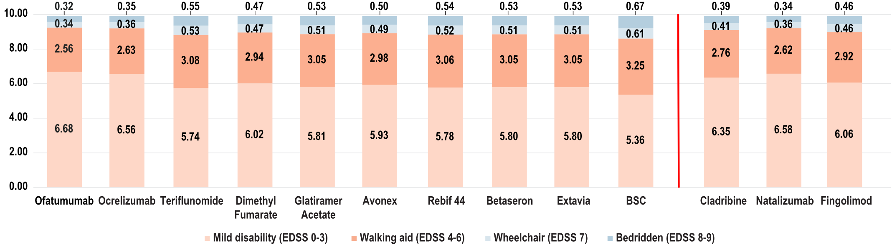
Supplementary Figure 1. Patient time (in years) in each EDSS health state over 10 years for first-line and second-line treatments without treatment switching or delay. Bars to the left and right of the red line represent first-line and second-line therapies, respectively. Values within the bars represent the number of years spent in each respective health state severity grouping. Abbreviations: BSC - best supportive care; EDSS - Expanded Disability Status Scale.

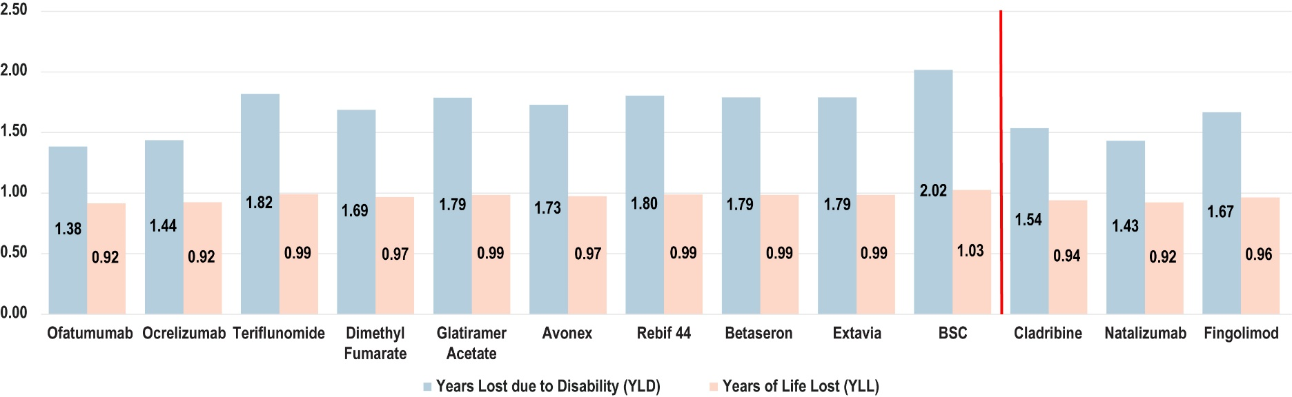
Supplementary Figure 2. YLD and YLL over 10 years for all first-line and second-line treatments without treatment switching or delay. Bars to the left and right of the red line represent first-line and second-line therapies, respectively. Values within the bars represent the absolute number of years lost due to disability and years of life lost over the 10-year period. To calculate YLLs, the number of deaths was multiplied by the remaining age- and sex-specific life expectancy of the general population at the time of death. To calculate the YLD, the number of patients in a particular EDSS state was multiplied by the MS-specific disability weights [3]. Abbreviations: BSC - best supportive care; YLD - years of life lost due to time lived in states of less than full health, or years of healthy life lost due to disability; YLL - years of life lost due to premature mortality.
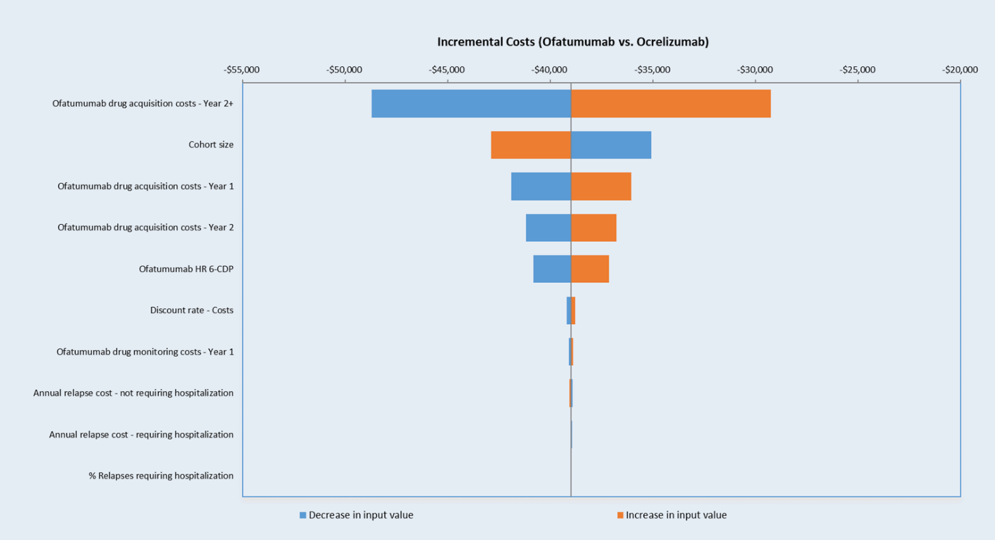
Supplementary Figure 3: Sensitivity Analysis results for Ofatumumab versus Ocrelizumab at 10-years. Key model parameters were varied by ±10% of the base case value. Abbreviations: CDP-6 - 6-month confirmed disability progression.
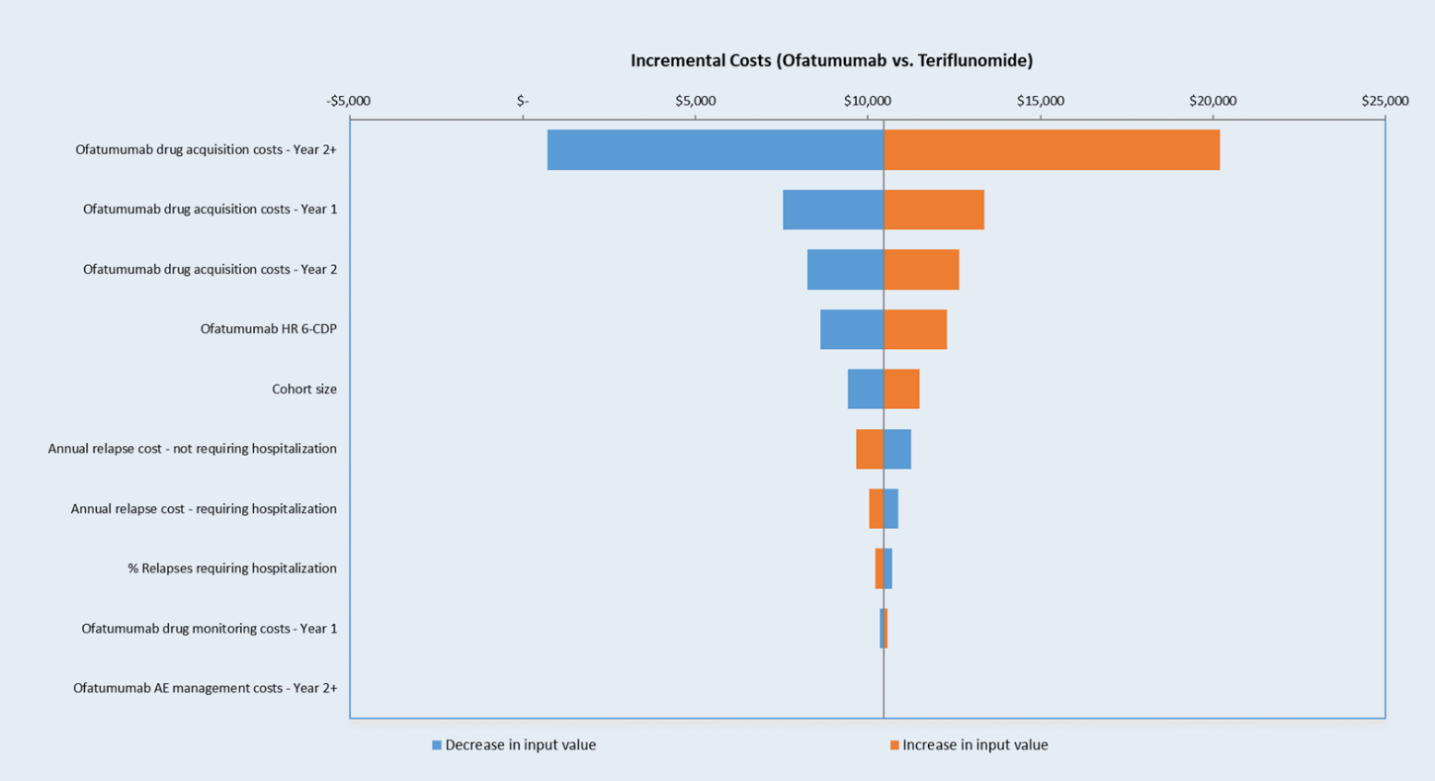
Supplementary Figure 4: Sensitivity Analysis results for Ofatumumab versus Teriflunomide at 10-years. Key model parameters were varied by ±10% of the base case value. Abbreviations: CDP-6 - 6-month confirmed disability progression.
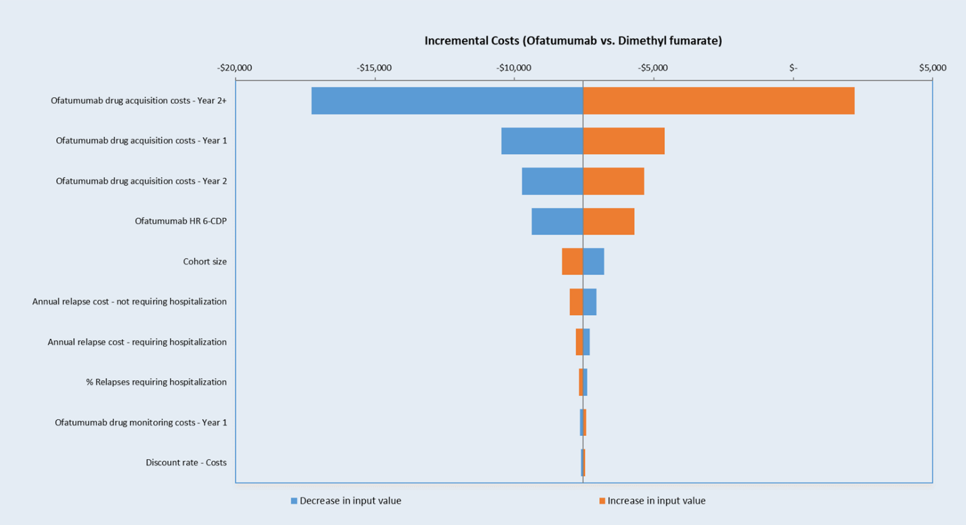
Supplementary Figure 5: Sensitivity Analysis results for Ofatumumab versus Dimethyl Fumarate at 10-years. Key model parameters were varied by ±10% of the base case value. Abbreviations: CDP-6 - 6-month confirmed disability progression.
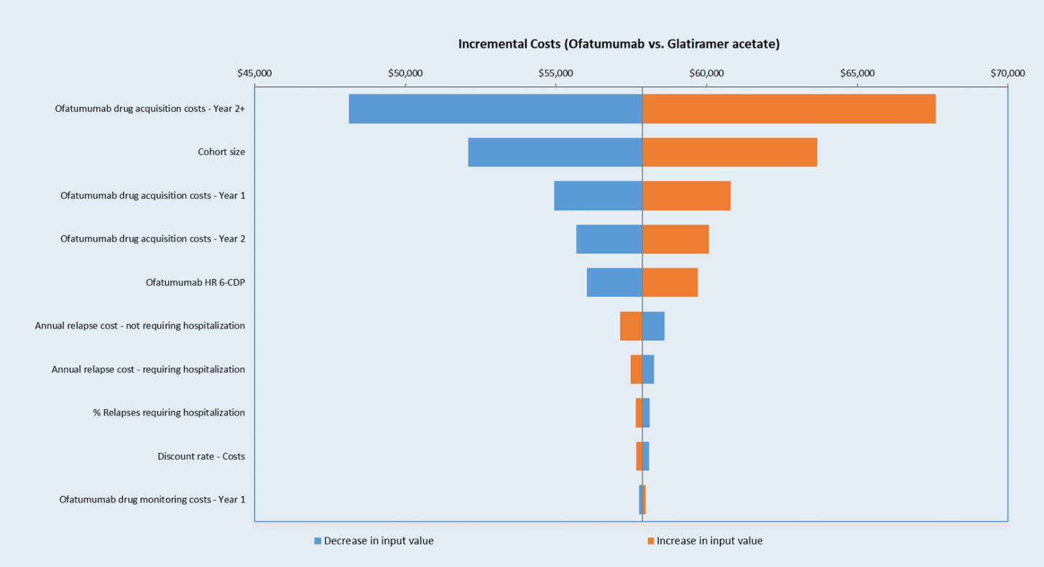
Supplementary Figure 6: Sensitivity Analysis results for Ofatumumab versus Glatiramer Acetate at 10-years. Key model parameters were varied by ±10% of the base case value. Abbreviations: CDP-6 - 6-month confirmed disability progression.
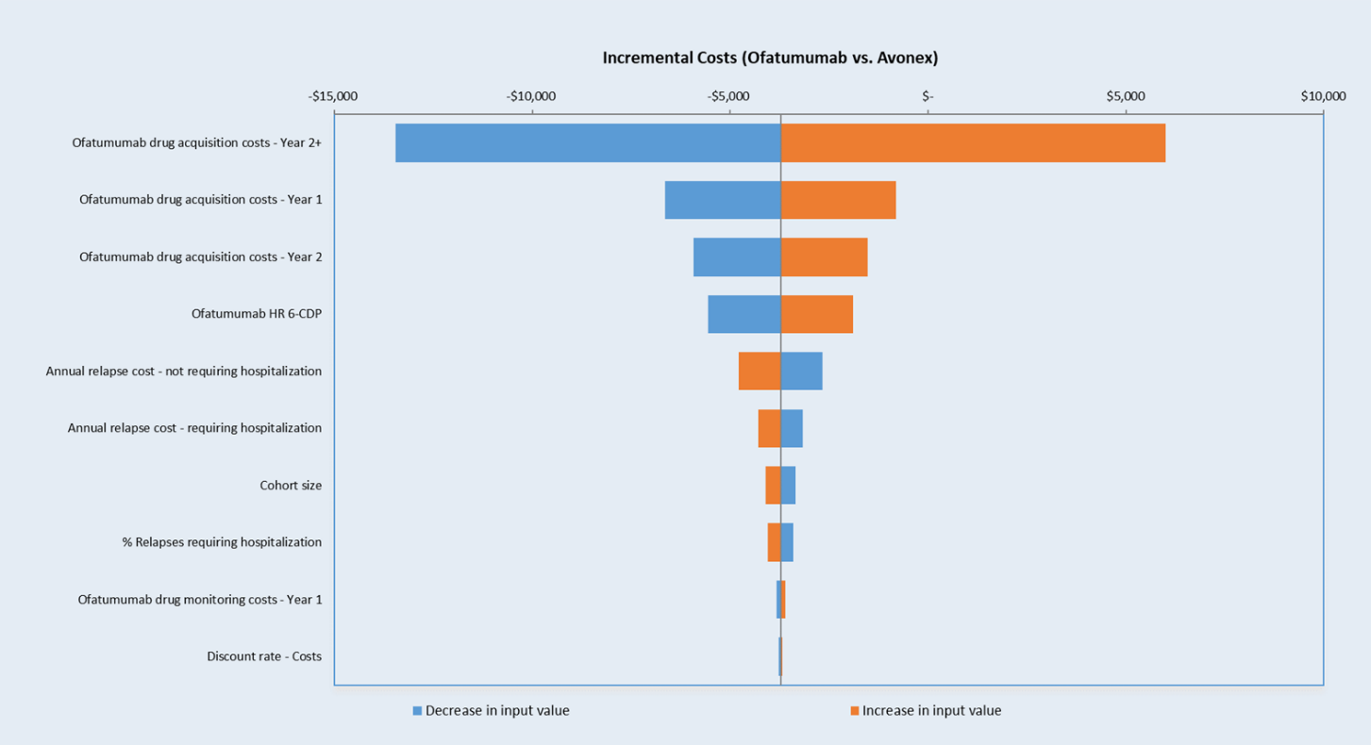
Supplementary Figure 7: Sensitivity Analysis results for Ofatumumab versus Avonex at 10-years. Key model parameters were varied by ±10% of the base case value. Abbreviations: CDP-6 - 6-month confirmed disability progression.
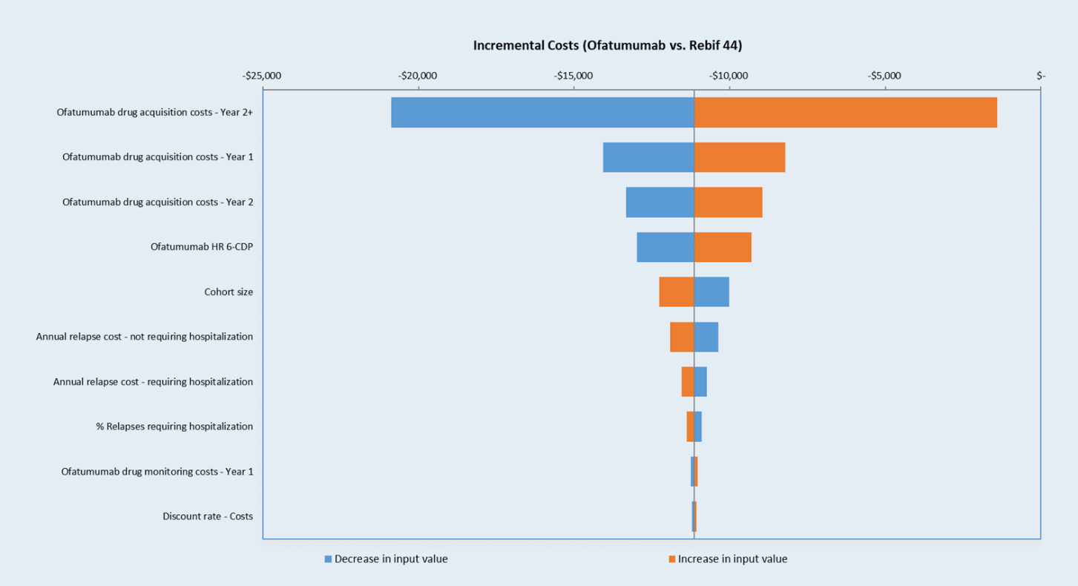
Supplementary Figure 8: Sensitivity Analysis results for Ofatumumab versus Rebif 44 at 10-years. Key model parameters were varied by ±10% of the base case value. Abbreviations: CDP-6 - 6-month confirmed disability progression.
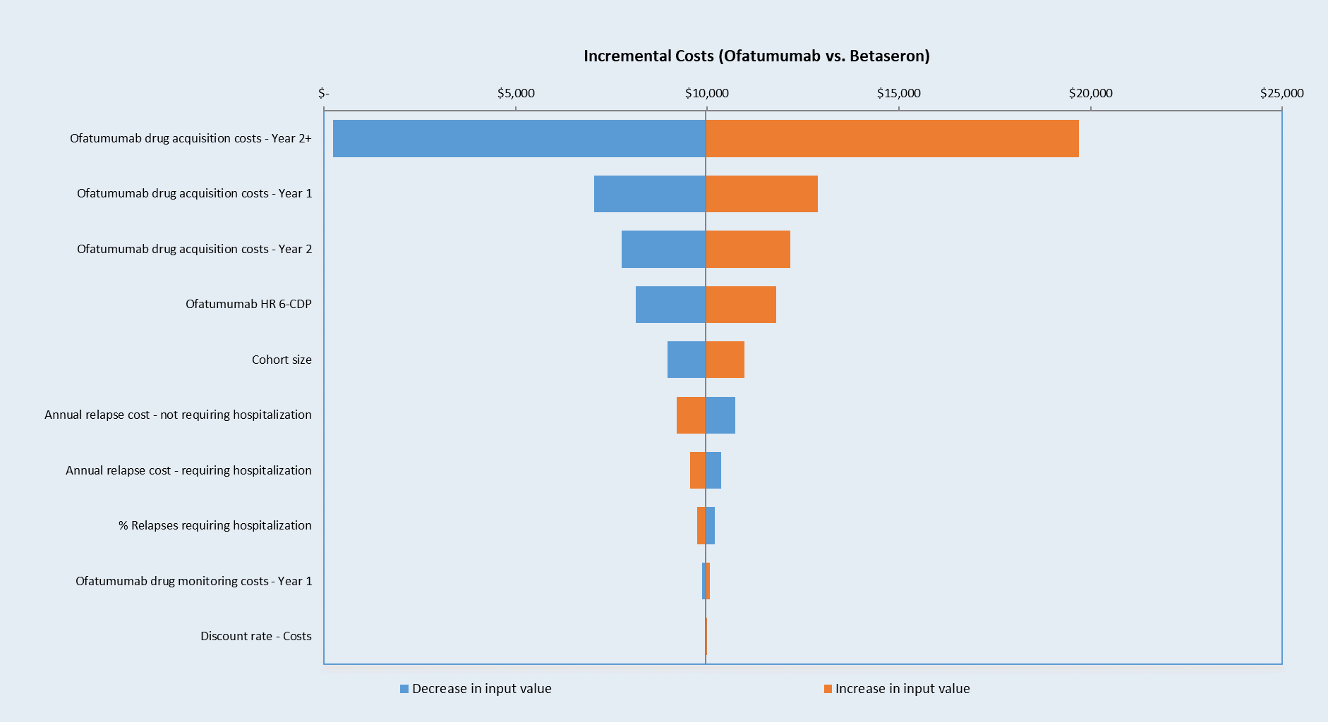
Supplementary Figure 9: Sensitivity Analysis results for Ofatumumab versus Betaseron at 10-years. Key model parameters were varied by ±10% of the base case value. Abbreviations: CDP-6 - 6-month confirmed disability progression.
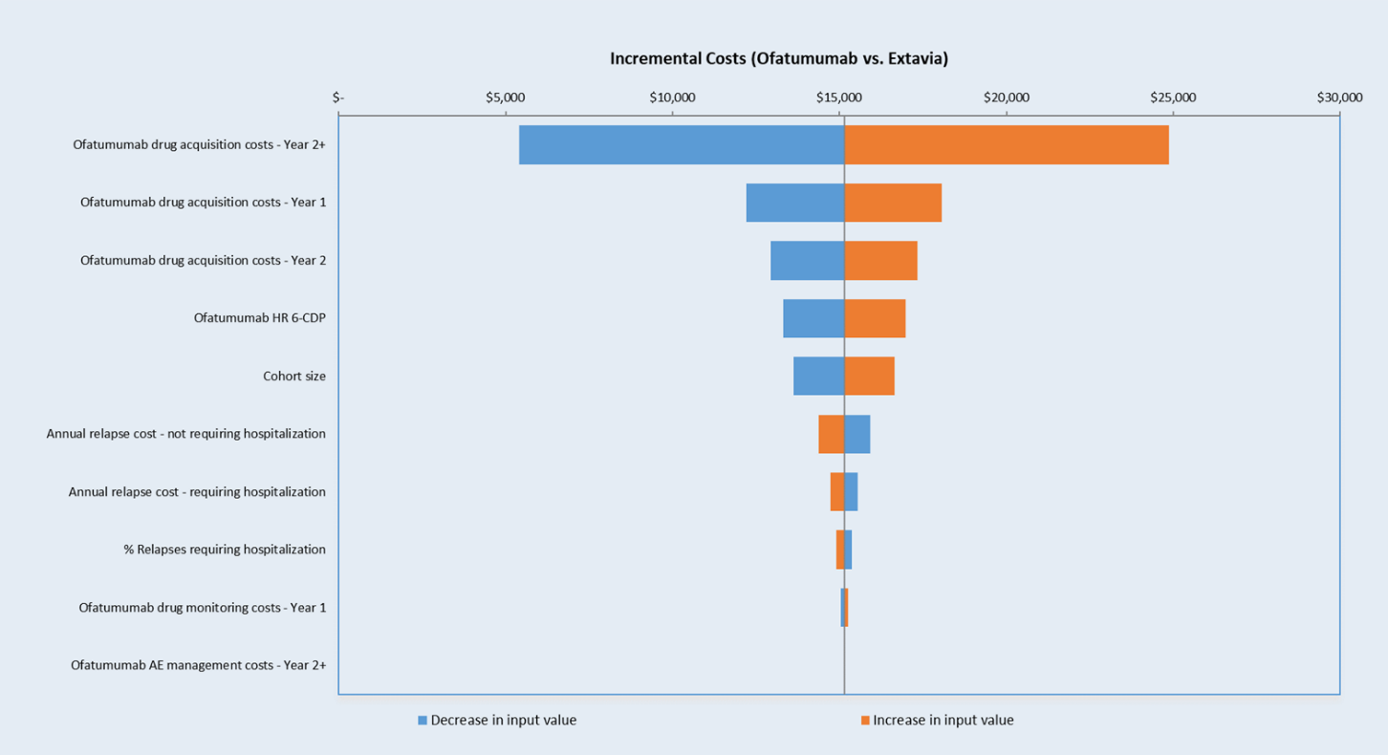
Supplementary Figure 10: Sensitivity Analysis results for Ofatumumab versus Extavia at 10-years. Key model parameters were varied by ±10% of the base case value. Abbreviations: CDP-6 - 6-month confirmed disability progression.
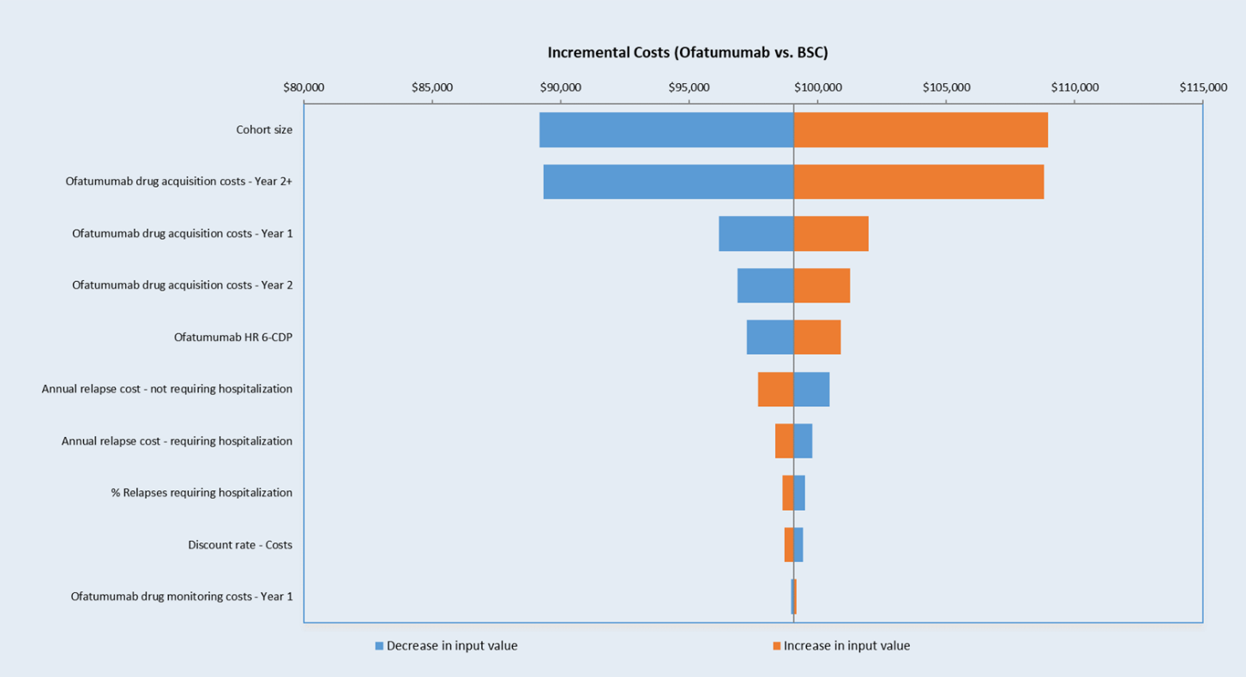
Supplementary Figure 11: Sensitivity Analysis results for Ofatumumab versus BSC at 10-years. Key model parameters were varied by ±10% of the base case value. Abbreviations: BSC – best supportive care; CDP-6 - 6-month confirmed disability progression.
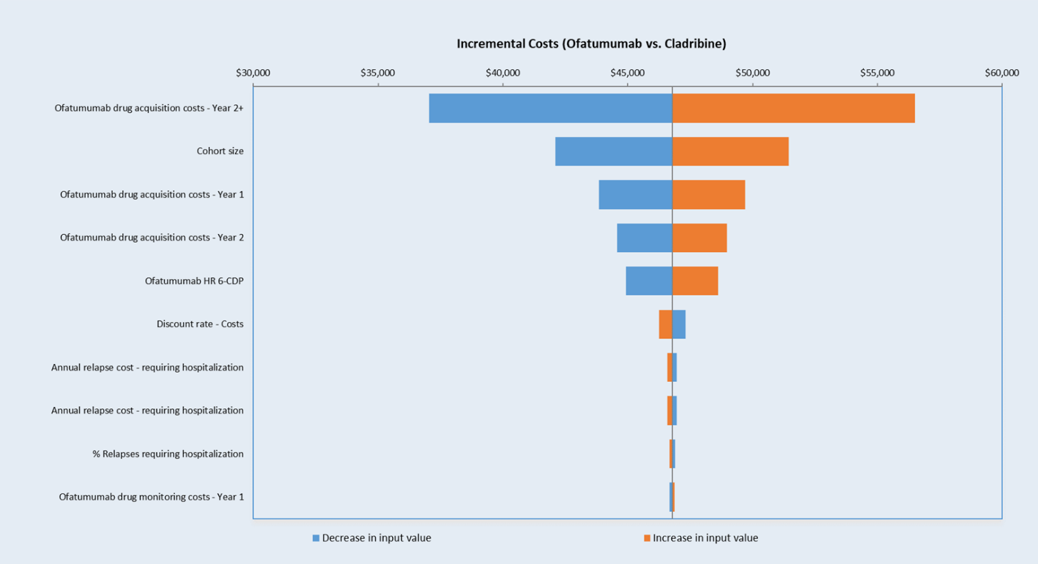
Supplementary Figure 12: Sensitivity Analysis results for Ofatumumab versus Cladribine at 10-years. Key model parameters were varied by ±10% of the base case value. Abbreviations: CDP-6 - 6-month confirmed disability progression.
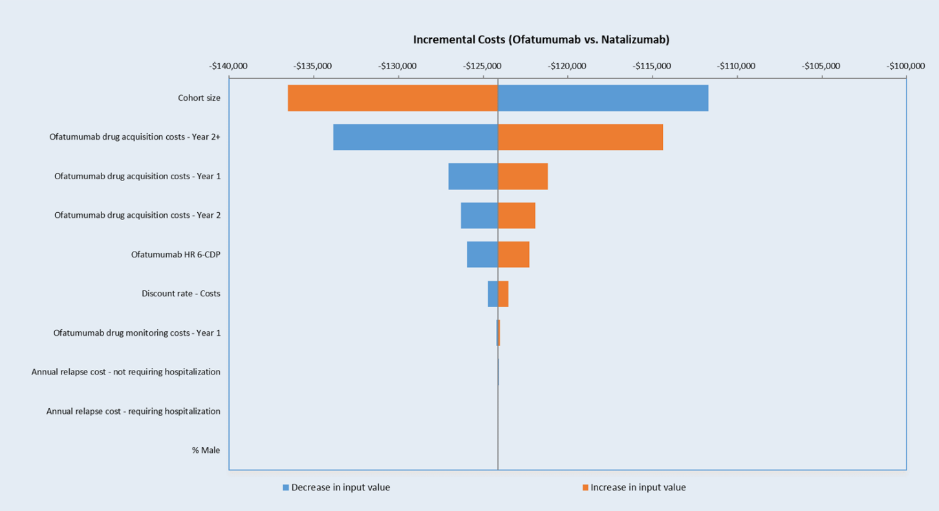
Supplementary Figure 13: Sensitivity Analysis results for Ofatumumab versus Natalizumab at 10-years. Key model parameters were varied by ±10% of the base case value. Abbreviations: CDP-6 - 6-month confirmed disability progression.
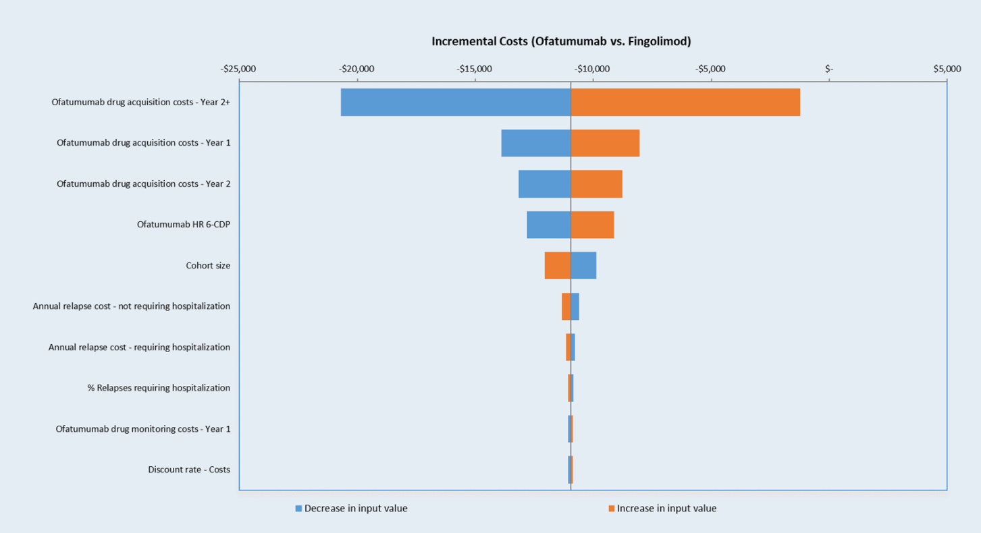
Supplementary Figure 14: Sensitivity Analysis results for Ofatumumab versus Fingolimod at 10-years. Key model parameters were varied by ±10% of the base case value. Abbreviations: CDP-6 - 6-month confirmed disability progression.

Reference List

1. Palace J, Bregenzer T, Tremlett H et al. UK multiple sclerosis risk-sharing scheme: a new natural history dataset and an improved Markov model. BMJ Open 4(1), e004073 (2014).
2. Pokorski RJ. Long-term survival experience of patients with multiple sclerosis. J Insur Med 29(2), 101-106 (1997).
3. Cho JY, Hong KS, Kim HJ et al. Disability weight for each level of the Expanded Disability Status Scale in multiple sclerosis. Mult Scler 20(9), 1217-1223 (2014).
4. Grima DT, Torrance GW, Francis G, Rice G, Rosner AJ, Lafortune L. Cost and health related quality of life consequences of multiple sclerosis. Mult Scler 6(2), 91-98 (2000).
5. Karampampa K, Gustavsson A, Miltenburger C, Kindundu CM, Selchen DH. Treatment experience, burden, and unmet needs (TRIBUNE) in multiple sclerosis: the costs and utilities of MS patients in Canada. J Popul Ther Clin Pharmacol 19(1), e11-25 (2012).
6. Samjoo IA, Worthington E, Drudge C et al. Comparison of ofatumumab and other disease-modifying therapies for relapsing multiple sclerosis: a network meta-analysis. J Comp Eff Res 9(18), 1255-1274 (2020).
7. Canadian Agency for Drugs and Technologies in Health. CDR Pharmacoeconomic Review Report for Lemtrada. Available at: https://www.cadth.ca/sites/default/files/cdr/pharmacoeconomic/SR0405_Lemtrada_RRMS_PE_Report.pdf (Accessed: April 2022).
8. Patwardhan MB, Matchar DB, Samsa GP, Mccrory DC, Williams RG, Li TT. Cost of multiple sclerosis by level of disability: a review of literature. Mult Scler 11(2), 232-239 (2005).
9. Canadian Agency for Drugs and Technologies in Health. CADTH Therapeutic Review: Comparative clinical and cost-effectiveness of drug therapies for relapsing-remitting multiple sclerosis [Internet]. Available at: http://www.cadth.ca/media/pdf/TR0004_RRMS_ScienceReport_e.pdf (Accessed: Jan 2020).
10. Government of Canada. Job Bank: Wages for Registered nurses and registered psychiatric nurses. Available at: https://www.jobbank.gc.ca/wagereport/occupation/993 (Accessed: April 2021).
11. Ontario Ministry of Health. Schedule of Benefits for Laboratory Services (Effective July 1, 2020). Available at: http://www.health.gov.on.ca/en/pro/programs/ohip/sob/lab/lab_mn2020.pdf (Accessed: January 2022).
12. Ontario Ministry of Health. Schedule of Benefits, Physician Services Under the Health Insurance Act (Effecive March 14, 2021). Available at: http://www.health.gov.on.ca/en/pro/programs/ohip/sob/physserv/sob_master20200306.pdf (Accessed: January 2022).
13. Ontario Case Costing. Costing Analysis Tool. Available at: https://hsimi.ca/occp/occpreports/ (Accessed: January 2022).
14. Tam VC, Ko YJ, Mittmann N et al. Cost-effectiveness of systemic therapies for metastatic pancreatic cancer. Curr Oncol 20(2), e90-e106 (2013).
15. Government of Ontario. Ontario Drug Benefit Formuarly. Available at: https://www.formulary.health.gov.on.ca/formulary/ (Accessed: January 2022).
16. Government of Alberta. Alberta Interactive Drug Benefit List. Available at: https://idbl.ab.bluecross.ca/idbl/load.do (Accessed: January 2022).
17. Chirikov V, Ma I, Joshi N et al. Cost-Effectiveness of Alemtuzumab in the Treatment of Relapsing Forms of Multiple Sclerosis in the United States. Value Health 22(2), 168-176 (2019).

